# Taskerman

## Activity Diagrams

### TaskerMAN Login

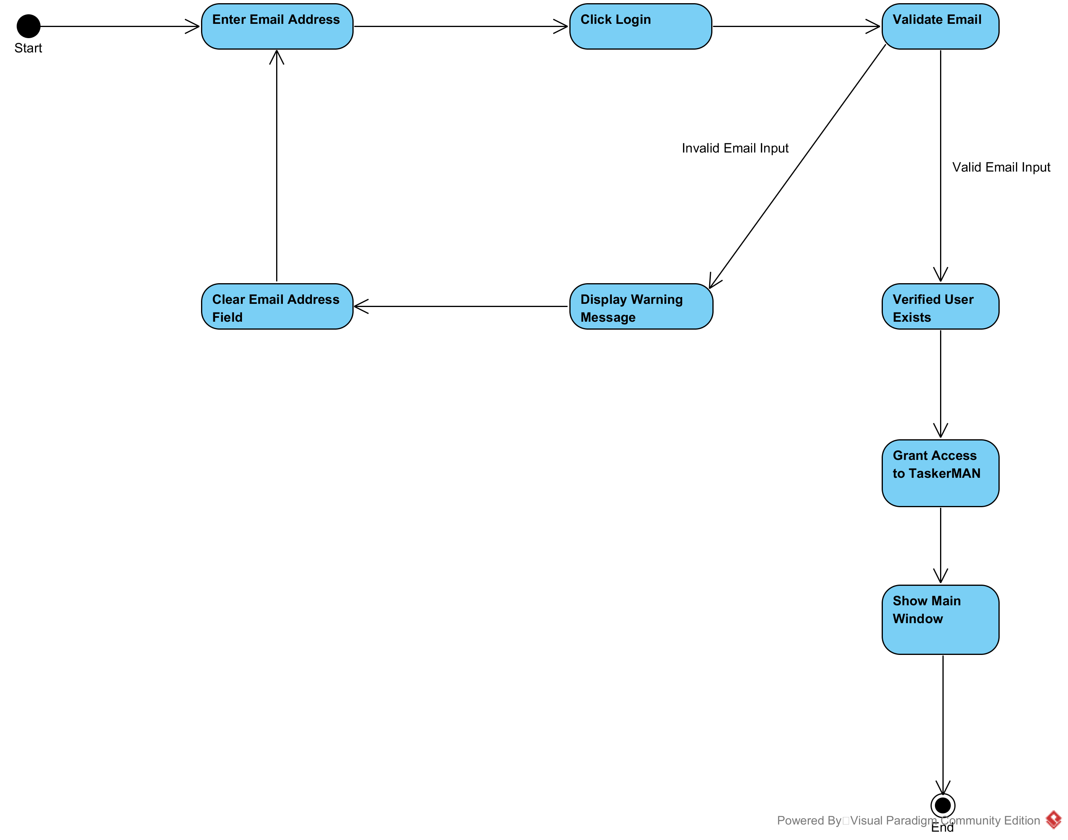

### Editing Tasks

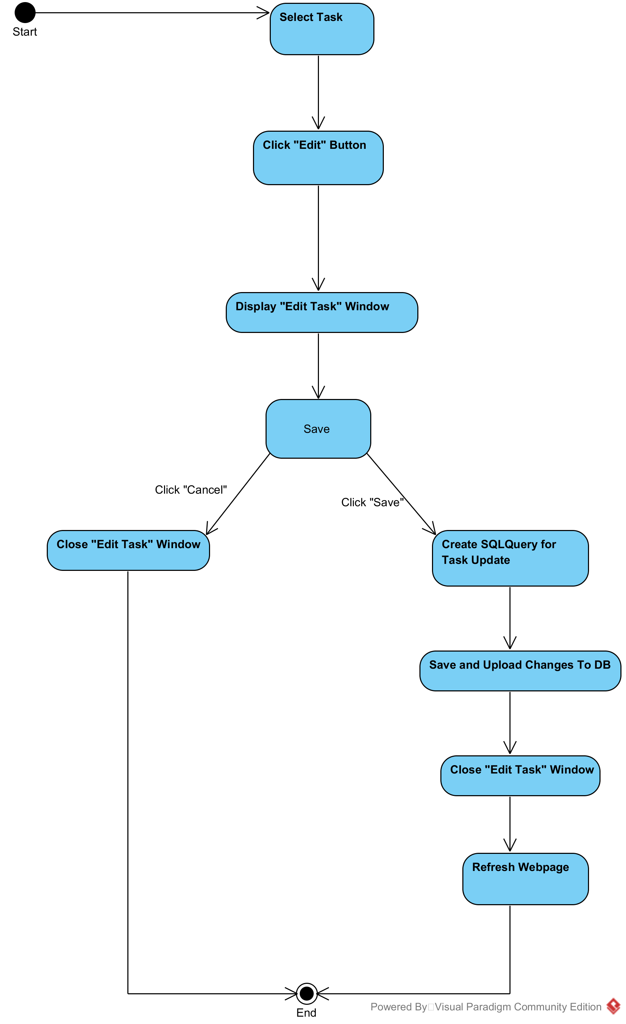

## Class Diagrams

### Object Oriented Classes

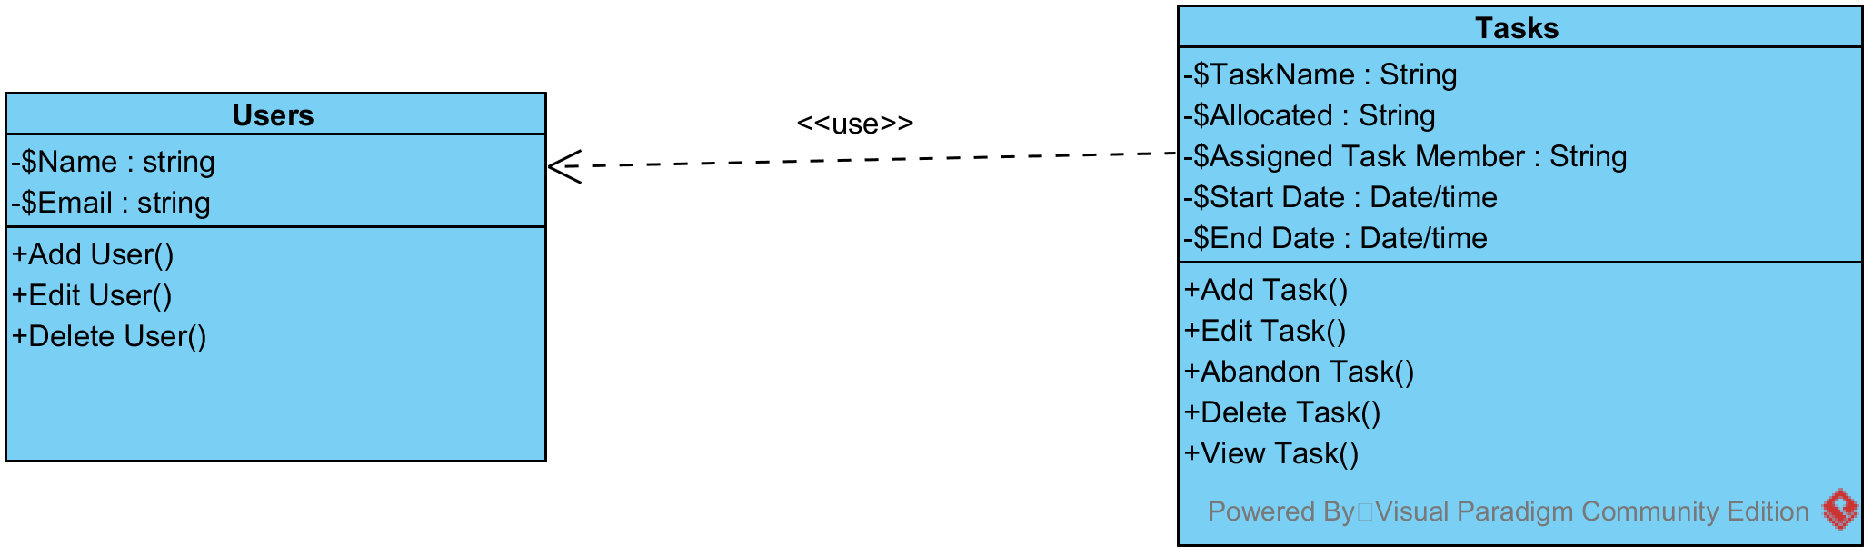

### Procedural Classes

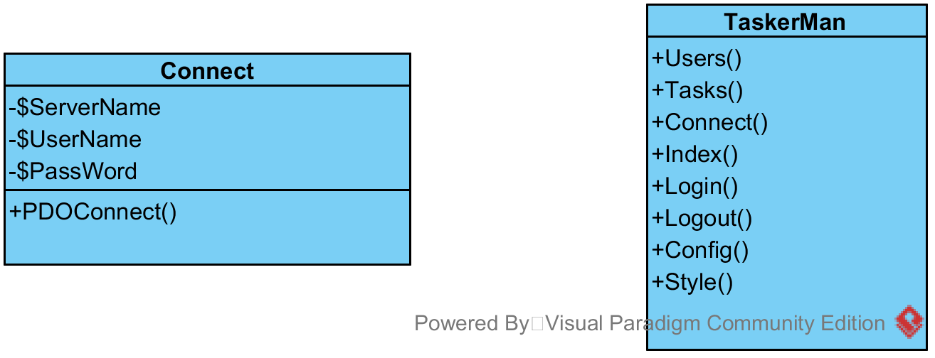

## Sequence Diagrams

### Connecting to TaskerSRV

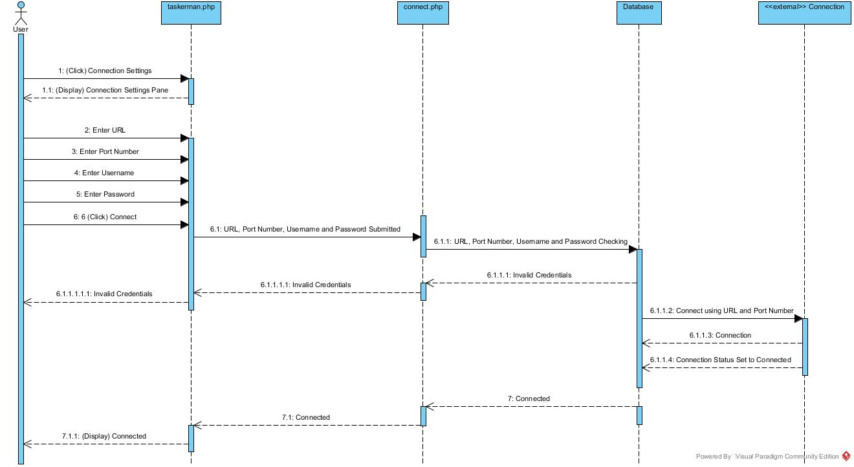

### TaskerMAN Login

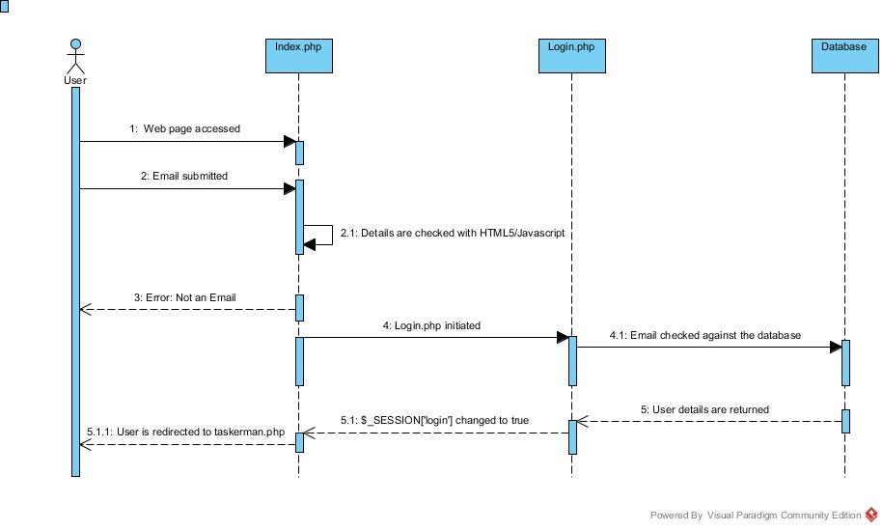

### Editing Tasks

